INFO 6055

Non-Functional Testing Assignment 2

## Student name : Amanjot kaur_______________________ Student

## ID : 0914790_______________________

## Description – Non-functional requirements

Simulated Load Test

Marks - 50

Instructions

Follow these instructions closely.

* This is an individual assignment
* Setup
  + Unzip the “InClass3.zip” file from FOL to the c: drive
  + The file must be unzipped to the root of C:
  + Start your windows “task manager” (see instructions below)
  + Run the java program provided in a command window or PowerShell
* Your company has purchased a new server for a business transaction application. You must test and assess this server for its performance. It must support 100 concurrent users with performance to spare.

If the server passes your company will purchase more.

You will use an automated tool that will execute one of the business transactions for 30 seconds. You will specify how many users will be executing the same transaction.

* Execution
  + Use the provided table to capture your results
  + Run a test with 1 user and record your results for CPU, memory and disc
  + Now run with 2 users
    - 3 user
    - 4, 5, 6, 7, 8, 9,10, 25, 50, 75, 80, 100
  + Answer the questions below.
  + Place the answers to the question in this document.

1. At which point do you believe the system is running at average load? Explain.

**A 1: System is running at average load when it takes five users because after that fluctuation comes at 6% in disk IO after suddenly increase in 1 more user.**

1. At which point do you believe the system is running at peak load? Explain

**A 2 :System is at peak load when 80 users use the same application as it decreased the Max cpu frequency to 136 %(as shown in table). It slows down the speed of cpu because of heavy and load. It is not on 100 user , in my opinion as system manage itself after 80 users how to use resources in most optimum way.**

1. Where did you see the most significant change? Explain

**A: It showed 6% disc IO at 6 no. of users or 10 no. of users .In my assumption, It may be due to suddenly increase in load and system need some time to handle the situation.**

1. What can you conclude from this test? Be thorough and explain your position and make your recommendation.

**Ans :In my opinion it all depend on system to system how much memory it will take or how it performs. Also, 80 user slows down cpu’s frequency than 100 users.**

1. Do you think this was a fair test of the server? Explain

**No, it is not as I said earlier no of user sometimes d’nt impact the system.It may be that the system busy in doing some tasks. Just like it shows different result at 6 and 10 users or 80 and 100 users. It dnt give justification why take take different resources at different users that may not relate to its numbers.**

1. Provide samples of your output.
   1. Provide screen shots of your results.
      1. 1 user – cpu

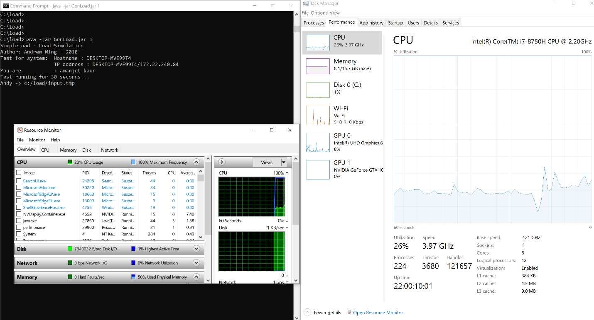

**1 user – cpu**

* + 1. 50 users - disc IO and memory (2 screenshots)

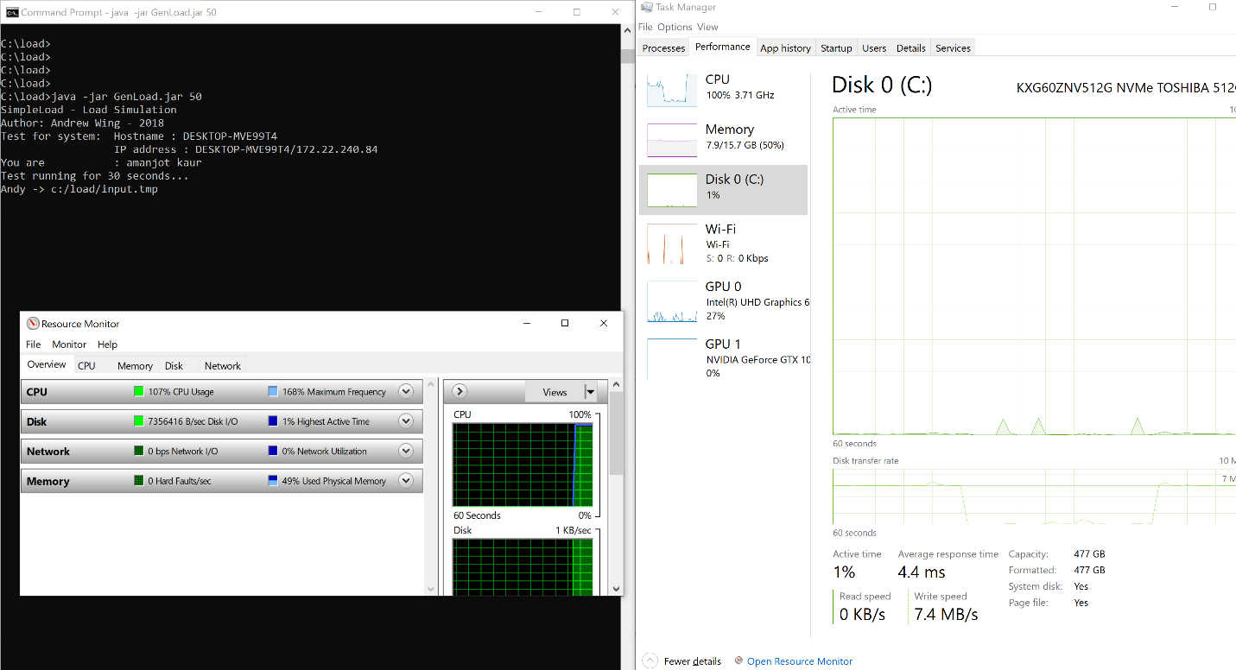

**DISK IO**

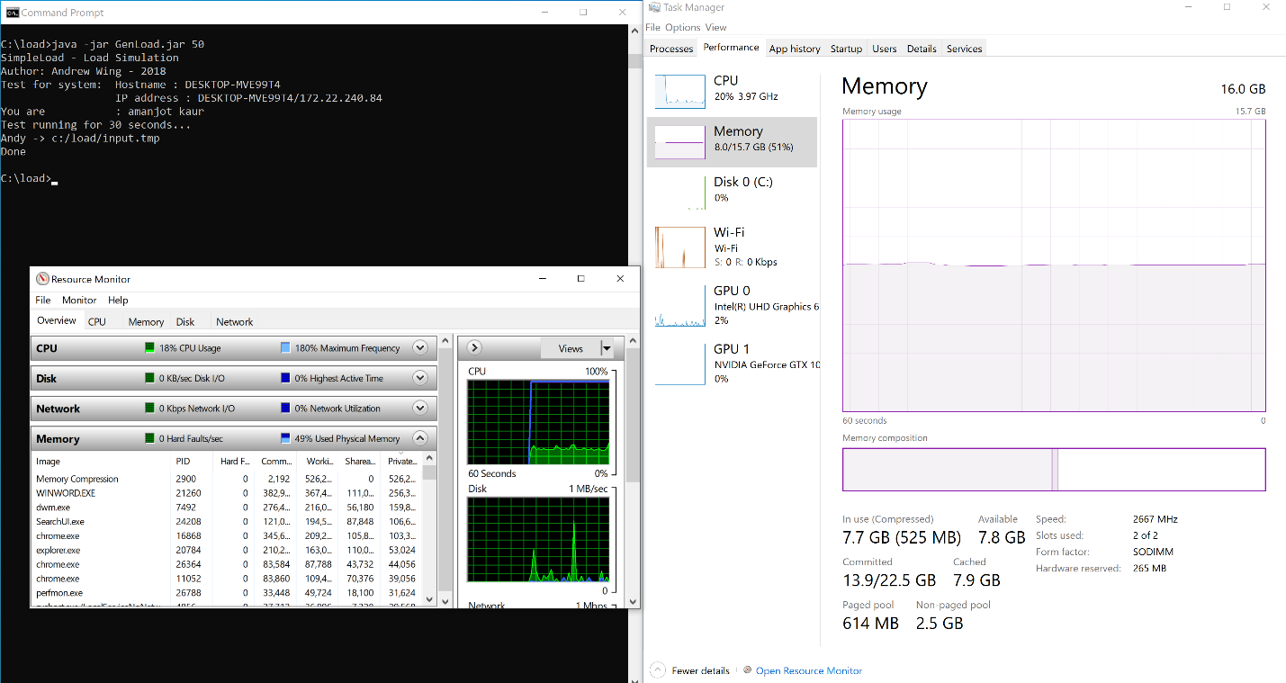

**MEMORY**

* + 1. 100 users – cpu

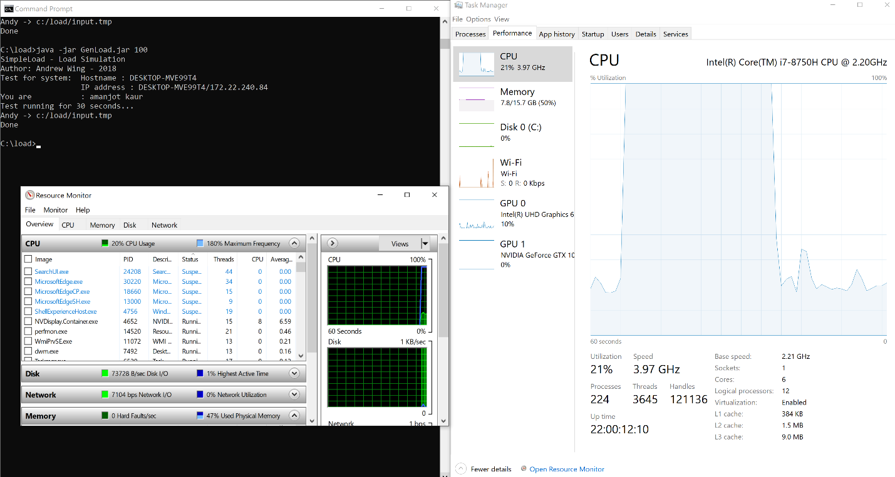

* 1. Make sure your screenshots include the console window with the running load simulator

You must submit this document to the “assignment Two” drop box.

The marking scheme is found on the last page.

Do not zip anything.

|  |  |  |  |
| --- | --- | --- | --- |
| Test - Users | CPU max | Memory max | Disc IO max |
|  |  |  |  |
| 1 | 180% max frequency | 48% used physical memory | 1% highest Active time |
| 2 | 180% max frequency | 49% used physical memory | 2% highest Active time |
| 3 | 178% max frequency | 50% used physical memory | 1% highest Active time |
| 4 | 180% max frequency | 49% used physical memory | 1% highest Active time |
| 5 | 179% max frequency | 49% used physical memory | 0% highest Active time |
| 6 | 181% max frequency | 48% used physical memory | 6% highest Active time |
| 7 | 179% max frequency | 49% used physical memory | 1% highest Active time |
| 8 | 177% max frequency | 49% used physical memory | 1% highest Active time |
| 9 | 177% max frequency | 49% used physical memory | 1% highest Active time |
| 10 | 183% max frequency | 48% used physical memory | 6% highest Active time |
| 25 | 178% max frequency | 49% used physical memory | 1% highest Active time |
| 50 | 168% max frequency | 49% used physical memory | 1% highest Active time |
| 75 | 161% max frequency | 50% used physical memory | 1% highest Active time |
| 80 | 136% max frequency | 49% used physical memory | 1% highest Active time |
| 100 | 159% max frequency | 49% used physical memory | 1% highest Active time |

* Setup Instructions - Task Manager
* Start the Task Manager

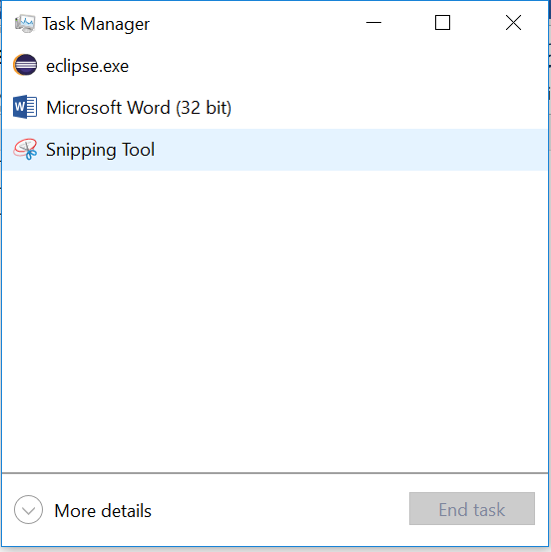 Select the “More details” link



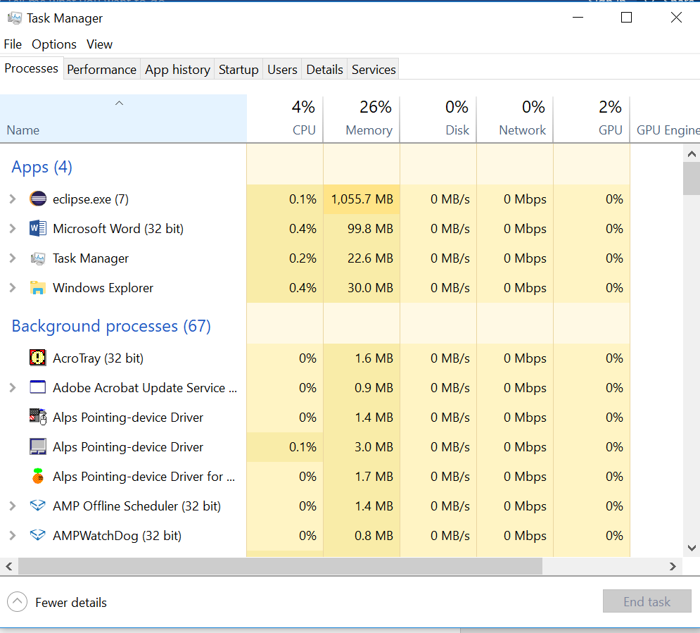 Select the “Performance” Tab



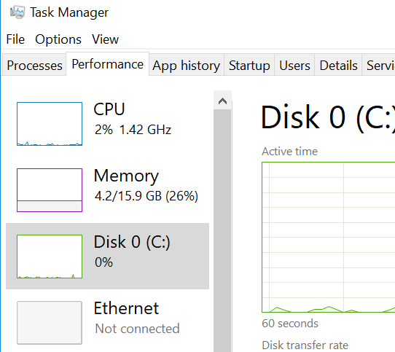 Use the selections on the left to see the appropriate graph while you test.

* Run the simulator
* The “GenLoad.jar” is in the load folder.
* Open a command window or powershell in the “load” folder
* Run the program for each test: java –jar GenLoad.jar #users
  + E.g. java –jar GenLoad.jar 25

## Marking Scheme:

|  |  |  |
| --- | --- | --- |
| **Marks Available** | **What Are the Marks Awarded For?** | **Marks Awarded** |
|  | | |
| **10** | **Recorded all tests correctly** |  |
| **5** | **All screenshot collected and are correct** |  |
| **30** | **Answers to questions thoroughly** |  |
| **5** | **Followed all instructions to the letter - spelling** |  |
| **___ 50** | **TOTAL MARKS** |  |